MY PILGRIMAGE ON GAMBIER ISLAND OFF THE COAST OF VANCOUVER, BRITISH COLUMBIA
Throughout each of my daily pilgrimages, some of which may evoke sufferings, challenges and uncertainties I have been blessed with God’s comforting words: Do not be afraid for I am with you (Isaiah 41:10). With the knowledge that God consistently walks beside me and sustains me I am encouraged to cross each threshold and take the next step.
Currently ‘my backpack’ contains a myriad of precious memories. One such memory concerns a pilgrimage that continues to fill me with wonder, joy, awe and gratitude.
Several years ago, I had an opportunity to study in Vancouver, British Columbia, Canada. Whilst there I engaged in all kinds of extraordinary learning experiences, one of which included a weekend spent with an Environmental Studies Group on Gambier Island, a sparsely populated island reached after a short after a ferry journey from mainland Vancouver.
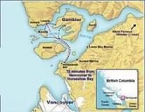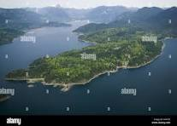
We gathered on a secluded part of the island. During the weekend there would be opportunities for us to develop orientation skills, stamina, creativity and to face unforeseen challenges.
Once assembled in an old disused barn where we were invited to taker a slip of paper from a bowl. Each slip indicated the latitude and longitude of what was to become our individual tent site for the night. Those of us who did not have tents were issued with a piece of transparent plastic and a length of string. Distribution thus completed each of us headed off to our designated geographical areas.
My destination took me to a rocky outcrop flanked by a raging stream making its way through a narrow canyon. I looked around and decided on the tent site. Between two adjacent trees I attached the length of string. The piece of transparent plastic was draped over the string, thus creating the beginnings of a crude tent. As the plastic was quite flimsy, I secured the lower extremities of the tent with loose rocks. The tent was beginning to take shape. Once inside of what was to be my haven for the night, I placed newspapers for insulation along the floor space, surveyed my sleeping place with pride and returned to the barn.
Back in the barn our evening meal consisting of bison, bread and mulled wine was being prepared by some of our versatile group. What a feast! The bison was gamey and took some chewing and the mulled wine had lulling effects on us. Stories were told around our ‘campfire’. John’s story had a great effect on me. He graphically described the grizzly bears that roamed freely on the island and emphasised that they were hungry at this time of year. What a worry! Individual’s fascinating stories gathered momentum and then it was time to set off for our tents. Each of us was equipped with a cut-out can housing a candle that was duly lit. We wished each other well and headed off into the wilderness, hopefully remembering the geographical location of our tent sites. So far, so good; there was not a sign of a bear as I made my way across an unmade path into the wilderness. I thankfully reached the tent and settled down for the night. Not wanting to draw attention to the candlelight beaming through the transparent plastic I decided to extinguish the candle and crawl into the safety of the sleeping bag.
Once settled we were to reflect on ourselves immersed in this wilderness. I experienced aloneness, connection with my lovely family and Sisters back home in Australia, and gratitude for the Environmental Studies Group who had taken me under their wing and brought me to this beautiful wild island. However, a large part of my reflections centred on the bears that were out there, possibly quite nearby, and probably ready to pounce. I listened for strange sounds and bear growls. I could detect a multitude of sounds emanating from the wind in the trees and the gurgling stream several metres below me. So far, I could not hear the lumbering footsteps of a bear, nor could I hear his heavy breathing and whetting of lips in preparation for a tasty Aussie meal! Suddenly there was a familiar sound. Heavy rain began pouring down, extinguishing any forest sounds. What bliss! Surely no bear would dare venture any further through the downpour. But there was another imminent danger. Would the flimsy tent withstand the elements and would the sleeping bag encasing me be borne off into the nearby raging stream? I waited expectantly, but all seemed to be well and eventually I must have gone to sleep.
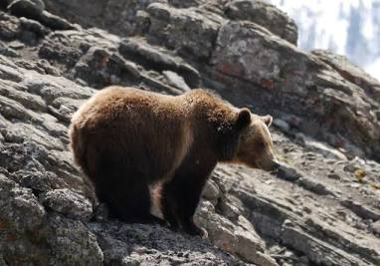
Morning broke and to my amazement I was dry. The rain had not penetrated the tent except for a slight dampness around the extremities. How extraordinary! I was amazed that my little flimsy ‘home’ had withstood such challenging weather.
We regrouped in a grassy patch. Whilst savouring porridge and hot drinks prepared over a fire made from rubbing sticks together, we shared our fascinating experiences of being alone in the wilderness.
I spoke of my fear of the ‘grizzlies’ and the merciful rain that drowned out the sounds of a potential bear invasion. To my surprise and subsequent shock, I learned that there were no bears on the island!! John certainly had taken delight in deceiving this gullible Aussie!
After breakfast we gathered in groups and began our initiation into the sessions that various students had prepared for us. We learned how to make a sauna out of heated rocks placed carefully in a plastic dome fashioned from a sheet of plastic. We learned how to recognise the native flora and fauna and how to select and chop logs for firewood.
Fortunately, we were on the island in time for the salmon spawning. How amazing that after swimming thousands of miles into the Pacific Ocean salmon return to the stream of their beginnings!
As we gazed reverently at some salmon making their last journey upstream, I noticed a female salmon who was struggling to make the distance. She kept losing her balance and was unable to remain upright to complete her last life-giving act. Suddenly I was overwhelmingly compelled to become a midwife. I waded into the stream and positioned my hands gently under the salmon’s limp body and held her respectfully. Once safe and still, she spawned her eggs. What a precious moment for me to be part of this heroic part of her life cycle! Once safe, I carefully released my hold on this beautiful fish. With great difficulty she swam to a quiet part of the stream and waited for her male counterpart to complete the life-giving process. The salmon’s mission was thus accomplished.
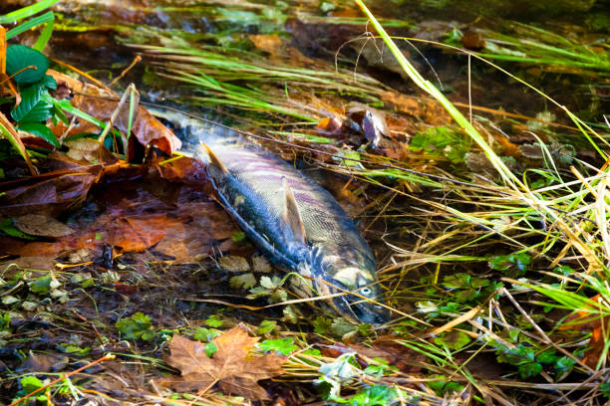
This breathtaking climax of a cycle of life is etched forever in my treasure chest of memories.
What a wonderful weekend it was! I am so grateful to the lovely Environmental Studies students for taking me to Gambier Island, for helping me to become more courageous, to develop new life skills and especially for allowing me to become a midwife!
Once again God had accompanied me on my pilgrimage, sustained in my fear and filled me with an overflowing measure of gratitude, joy, wonder and awe. I thought too of the salmon who had completed her long Pilgrimage of Hope. She had completed her life-cycle and was providing hope for the future by ensuring that there would continue to be salmon in the Pacific Ocean.

