- Films Plus:
The films will be accompanied by a D&M.
In Sept. we will be screening “Three Billboards outside Ebbing, Missouri; and in November “The Shack”.

Presenter: Angela Dewar
Dates: Sept. 10th. Nov. 12th.

- “There’s a hole in my chest” – Healing & Hope for Adult Children Everywhere.

Often our parents for various reasons were unable to give us all the life skills we needed. This day will assist you to identify the skills you missed out on and help you heal those childhood wounds.

Presenter: Sr. Joan
Date: 12th Sept.
As the Focus Week is fully booked, we decided to take a section of the week
and offer it as a Day Progra

- Crossroads & Threshholds
“As we stand at the thresholds, life itself is commissioning us to move on to a new stage of our Becoming. Something at the core of being is urging us forward…” M. Silf – Sacred Spaces
Presenter: Sr Michele Toussaint fcs Date: November 13th

“Kewn Kreestha” (KK)– the Family Care Sisters’ Wholistic centre provides for the
physical, emotional, spiritual and social well-
being of women.

KK is not a Hospital or a Mental Health facility.

KK operates February to mid-December each year.

Prayer Days:
Are offered through the year and information
re: topics and venue, sent via email.
If not on the mailing list and you would
like to receive information, email us and
advise.

Focus Weeks: To attend a Focus week Guest
must have participated in a Regular Program week.

In 2018 – 2 Focus weeks are being offered.

Both Focus Weeks booked out early.

Short Stay: Residential.
Guests may stay 1 or more nights.
Sessions provided, attendance optional.

All Short stays are booked out.

70+ Week: July 23rd - 27th

Day Programs: 10am – 3pm
Cost: $25 per session. $20 concession.
Time: 9.50am arrival for 10am start
BYO: Lunch. M/Tea provided.
Venue: Meeting Room
Bookings essential for all programs.

Residential Programs:
Cost of stay:
$40 per day. GST inclusive.

A Deposit of $30 is required prior to
any booking being confirmed.
If no Deposit received within 5 days of initial call, booking may be cancelled.

Direct deposit is preferred method
for payment.
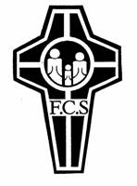
Banking Details:
Bank: Commonwealth Bank
Name: Family Care Sisters
BSB: 06 3124
Ac No. 1077 9929
Under description: write your name
& surname. Advise via email
when deposit is made.
E: resthome.familycare@bigpond.com

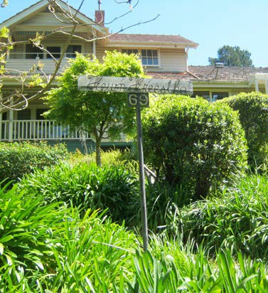
Wholi

Wholistic Centre

Day Programs for 2018

69 Alto Ave. Croydon. 3136
Phone: 03 9723 6797 (M-F)
Web: Family Care Sisters / Sisters of Mercy

Family Care

New Day Programs and Sessions
will be advised via email.

If you wish to receive notifications
- Please email and advise that you
wish to be placed on the database.

69 Alto Ave. Croydon. 3136
Phone: 03 9723 6797 (M-F)
Web: Family Care Sisters / Sisters of Mercy
Email:
resthome.familycare@bigpond.com

