- Films Plus:
Back by popular demand! This year we are again offering films accompanied by a D&M.
The selection of 4 films will be advised via email. Attend 1, 2, 3 or 4.

Presenter: Angela Dewar
Dates: Mar. 13th. April 23rd.
Sept. 10th. Nov. 12th.

- SBNR – Spiritual But Not Religious
If you identify with this statement you are invited to attend this one day program.
It will provide the opportunity for you to both reflect and discuss the importance of spirituality in your daily life.

Presenter: Sue Gesell
Date: Mar. 16th

- The Gift of Gratitude.
“Gratitude makes sense of our past, brings peace for today and creates a vision for tomorrow.” Melody Beattie

Presenter: Sr Gwen Daw sjc
Date: May 14th

- Feminine Spirituality
Suitable for new or continuing participants.

Exploring Feminine spirituality from a woman’s point of view and how it impacts on life.

Presenter: Margaret Carman
Dates: May 15th & June 12th

- Gathering the Fragments
“You can’t always change things, sometimes you have no control over the way things go…. you’re just given so much to work with in a life and you have to do the best you can with what you got.” Mary quoted in “The Quilters – Women & Domestic Art, an Oral History.”

Presenter: Sr. Michele Toussaint fcs
Date: May 16th

- A Spirituality for Married Life
Suitable for new or continuing participants.

An exploration of marital spirituality will help you understand the tension, confusion
and conflict that is inevitable in most marriages. We will identify seven developmental processes in ‘marriage’ and use our combined wisdom to explore these processes.

A Spirituality for the married life will not solve your problems, but it will provide you with the freedom to make wise choices.

Presenter: Sue Gesell
Dates: June 13th & July 18th & August 15th

- “Claiming my Freedom”.
A closer look at Boundaries – based on the work of Henry Cloud and John Townsend

Presenter: Sr Gwen Daw sjc
Date: July 17th

- The Millers Tale - by M. Silf.
This story reveals shafts of God’s mystery, tracing creation’s story, from original blessing, through brokenness and restoration, to a vision of a new and never ending Kingdom in which we are all called to be co-creators.

Presenter: Angela Dewar
Date: August 14th & September 11th.

- The Necessary Rice - M. Silf
In this story of the Necessary Rice, some of the scenarios of human frailty and compulsion are explored.
Presenter: Angela Dewar
Date: October 16th

- Creating a Mandala.
Presenter: Angela Dewar
Date: October 17th

- Crossroads & Threshholds
“As we stand at the thresholds, life itself is commissioning us to move on to a new stage of our Becoming. Something at the core of being is urging us forward…” M. Silf – Sacred Spaces
Presenter: Sr Michele Toussaint fcs Date: November 13th

- Conversations with a Pumpkin. - M. Silf
All we can change is ourselves, and our own perceptions. This story explores what it can mean and what it can cost, to let go of the protective shell of our ego selves to make way for Cinderella’s coach of transformation.
Presenter: Angela Dewar
Date: November 14th

“Kewn Kreestha” (KK)– the Family Care Sisters’ Wholistic centre provides for the
physical, emotional, spiritual and social well-
being of women.

KK is not a Hospital or a Mental Health facility.

KK operates February to mid-December each year.

Prayer Days:
April 24th: June 6th: July 16th
Information re: topics will be sent via email.

Focus Weeks: To attend a Focus week Guest
must have participated in a Regular Program week.

In 2018 – 2 Focus weeks are being offered.
- “Too soon Old, Too late smart”
- Growing into Wisdom.
9th-13th April 2018

- “The hole in my chest”.
- Healing & Hope for adult children everywhere.
6th-10th August 2018

Short Stay: Residential.
Guests may stay 1 or more nights.
Sessions provided, attendance optional.
March. 5th – 8th
April 16th – 19th Home 10am
Sept. 17th – 20th

70+ Week: July 23rd - 27th
Day Programs: 10am – 3pm
For programs with more than 1 session, attendance is required at all sessions.

Cost: $25 per session. $20 concession.
Time: 9.50am arrival for 10am start
BYO: Lunch. M/Tea provided.
Venue: Meeting Room

Bookings essential for all programs.

Residential Programs:
Cost of stay:
$40 per day. GST inclusive.

A Deposit of $30 is required prior to
any booking being confirmed.
If no Deposit received within 5 days of initial call, booking may be cancelled.

Direct deposit is preferred method
for payment.

Banking Details:
Bank: Commonwealth Bank
Name: Family Care Sisters
BSB: 06 3113
Ac No. 1091 6426
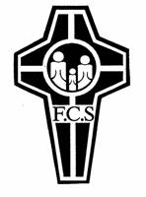
Under description: write your name
& surname. Advise via email
when deposit is made.
E: resthome.familycare@bigpond.com

All Donations over $2 are Tax Deductible
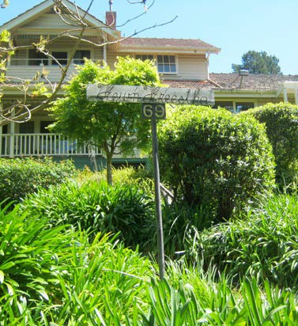
Wholi

Whol

Wholistic Centre

Day Programs for 2018

Family Care

69 Alto Ave. Croydon. 3136
Phone: 03 9723 6797 (M-F)
Web: Family Care Sisters / Sisters of Mercy

